BRAIN TUMOUR DETECTION
21CSP302L- PROJECT
Submitted by
YASH RAJ [RA2311056010263]
SANJANA JAISWAL[RA2311056010270]
JATIN REDHU[RA2311056010303]

Under the Guidance of

Dr. SHOBANA J

Associate professor
Department of Data Science and Business System

in partial fulfillment of the requirements for the degree of

BACHELOR OF TECHNOLOGY

in

COMPUTER SCIENCE ENGINEERING

with specialization in DATA SCIENCE


DEPARTMENT OF DATA SCIENCE AND

BUSINESS SYSTEMS
SRM INSTITUTE OF SCIENCE AND TECHNOLOGY

KATTANKULATHUR- 603 203

MAY 2026


Department of Computational Intelligence

SRM Institute of Science & Technology

Declaration Form

Degree/ Course : B. Tech/Data Science

Student Name : Yash Raj, Sanjana Jaiswal, Jatin Redhu

Registration Number : RA2311056010263, RA2311056010270, RA2311056010303

Title of Work : Brain Tumor Detection
I / We hereby certify that this assessment compiles with the University’s Rules and Regulations relating to Academic misconduct and plagiarism, as listed in the University Website, Regulations, and the Education Committee guidelines.

I / We confirm that all the work contained in this assessment is my / our own except where indicated, and that I / We have met the following conditions:

- Clearly referenced / listed all sources as appropriate
- Referenced and put in inverted commas all quoted text (from books, web, etc)
- Given the sources of all pictures, data etc. that are not my own
- Not made any use of the report(s) or essay(s) of any other student(s) either past or present
- Acknowledged in appropriate places any help that I have received from others (e.g. fellow students, technicians, statisticians, external sources)
- Compiled with any other plagiarism criteria specified in the Course handbook / University website
I understand that any false claim for this work will be penalized in accordance with the University policies and regulations.
DECLARATION:
I am aware of and understand the University’s policy on Academic misconduct and plagiarism and I certify that this assessment is my / our own work, except where indicated by referring, and that I have followed the good academic practices noted above.

YASH RAJ SANJANA JAISWAL JATIN REDHU
(RA2311056010263 (RA2311056010270 (RA2311056010303)



SRM INSTITUTE OF SCIENCE AND TECHNOLOGY KATTANKULATHUR – 603 203

BONAFIDE CERTIFICATE

Certified that 21CSP302L - Project report titled “BRAIN TUMOR DETECTION” is the bonafide work of “Yash Raj [RA2311056010263], Sanjana Jaiswal [RA2311056010270], Jatin Redhu [RA2311056010303]” who carried out the project work under my supervision. Certified further, that to the best of my knowledge the work reported herein does not form any other project report or dissertation on the basis of which a degree or award was conferred on an earlier occasion on this or any other candidate.

SIGNATURE  Dr. SHOBANA J  ASSOCIATE PROFESSOR  DEPARTMENT OF  DATA SCIENCE &  BUSINESS SYSTEM |  | SIGNATURE  Dr. KAVITHA V  PROFESSOR &HEAD  DEPARTMENT OF  DATA SCIENCE &  BUSINESS SYSTEMS

EXAMINER 1 EXAMINER 2

ACKNOWLEDGEMENTS

We express our humble gratitude to Dr. C. Muthamizhchelvan, Vice-Chancellor, SRM Institute of Science and Technology, for the facilities extended for the project work and his continued support.

We extend our sincere thanks to Dr. Leenus Jesu Martin M, Dean-CET, SRM Institute of Science and Technology, for his invaluable support.

We wish to thank Dr. Revathi Venkataraman, Professor and Chairperson, School of Computing, SRM Institute of Science and Technology, for her support throughout the project work.

We encompass our sincere thanks to, Dr. M. Pushpalatha, Professor and Associate Chairperson - CS, School of Computing and Dr.C. Lakshmi, Professor and Associate Chairperson -AI, School of Computing, SRM Institute of Science and Technology, for their invaluable support.

We are incredibly grateful to our Head of the Department, Dr. Kavitha V, SRM Institute of Science and Technology, for her suggestions and encouragement at all the stages of the project work.

We want to convey our thanks to our Project Coordinators, Panel Head, and Panel Members Department of Computational Intelligence, SRM Institute of Science and Technology, for their inputs during the project reviews and support.

We register our immeasurable thanks to our Faculty Advisor Dr. Dhanalakshmi J, Department of Data Science and Business Systems, SRM Institute of Science and Technology, for leading and helping us to complete our course.

Our inexpressible respect and thanks to our guide, Dr. Shobana J Department of Data Science and Business Systems, SRM Institute of Science and Technology, for providing us with an opportunity to pursue our project under his / her mentorship. He / She provided us with the freedom and support to explore the research topics of our interest. His / Her passion for solving problems and making a difference in the world has always been inspiring.

We sincerely thank all the staff members of Data Science and Business Systems, School of Computing, S.R.M Institute of Science and Technology, for their help during our project. Finally, we would like to thank our parents, family members, and
friends for their unconditional love, constant support and encouragement

YASH RAJ (RA2311056010263)
SANJANA JAISWAL (RA2311056010270)
JATIN REDHU (RA2311056010303)

ABSTRACT

Brain tumor diagnosis from MRI scans demands both precise spatial localization and accurate pathological classification, yet most existing approaches treat these as isolated tasks, failing to exploit the complementary nature of the two objectives. This paper presents a multi-task deep learning framework that simultaneously performs tumor segmentation and four-class classification from contrast-enhanced T1-weighted MRI scans, trained and evaluated on the BRISC 2025 dataset comprising approximately 6,000 images spanning three anatomical planes — axial, coronal, and sagittal — across four categories: glioma, meningioma, pituitary adenoma, and no tumor.
The proposed architecture, MultiTaskUNet, combines a pretrained EfficientNetB3 encoder with a UNet++ decoder augmented by scSE (spatial and channel squeeze-and-excitation) attention modules, enabling shared feature extraction for both tasks within a single forward pass. The segmentation head produces three-class pixel-wise predictions, while the classification head operates directly on the encoder's bottleneck features via global average pooling. A combined loss function balances multi-class Dice loss and cross-entropy across both tasks. Training followed a two-phase strategy: an initial phase with a frozen encoder to stabilize decoder learning, followed by a dual-loader fine-tuning phase that introduced a class-balanced classification loader alongside the segmentation loader, with staged encoder unfreezing and a reduced learning rate to prevent catastrophic forgetting. This approach yielded substantial performance gains over the frozen-encoder baseline. Evaluated on held-out test sets, the model achieves a mean Dice score of 0.890 for segmentation and 0.99 accuracy with 0.99 macro F1-score for classification, demonstrating strong generalization across tumor types, anatomical planes, and the class-imbalanced no-tumor category.

.

TABLE OF CONTENTS
ABSTRACT v

TABLE OF CONTENTS vi

LIST OF FIGURES vii

LIST OF TABLES viii

ABBREVIATIONS ix

CHAPTER TITLE PAGE
NO. NO.

1 INTRODUCTION 1
  - Introduction to Project 2
  - Problem Statement and Description 3
  - Motivation 4
  - Sustainable Development Goal of the Project 5
2 LITERATURE SURVEY 6
2.1 Overview of the Research Area 7
2.2 Existing Models and Frameworks 8
2.3 Limitations Identified from Literature Survey (Research Gaps) 11
2.4 Research Objectives 12
2.5 Product Backlog (Key user stories with Desired outcomes) 13
2.5 Plan of Action (Project Road Map) 15

3 SPRINT PLANNING AND EXECTION METHODOLOGY 21
3.1 SPRINT I 21
3.1.1 Objectives with user stories of Sprint I 23
3.1.2 Functional Document 25
3.1.3 Architecture Document 28
3.1.4 Outcome of objectives/ Result Analysis 29
3.1.5 Sprint Retrospective 30
3.2 SPRINT II 31
3.2.1 Objectives with user stories of Sprint II 32
3.2.2 Functional Document 33
3.2.3 Architecture Document 34
3.2.4 Outcome of objectives/ Result Analysis 35
3.2.5 Sprint Retrospective 36

4 RESULTS AND DISCUSSIONS 37
4.1 Project Outcomes (Performance Evaluation, Comparisons, Testing Results ) 38
5 CONCLUSION AND FUTURE ENHANCEMENT 39
REFERENCES 40
APPENDIX 41
A CODING 43
B CONFERENCE PUBLICATION 48
C JOURNAL PUBLICATION 50
D PLAGIARISM REPORT 51

LIST OF FIGURES

CHAPTER NO | TITLE | PAGE NO.
3.1.1 | MS Planner Board of Brain Tumor Detection
3.1.2 | Functional Document
3.1.3 | Architecture Document
3.1.4 | Sprint 1 Outcomes
3.2.3 | Architecture Document
3.2.4 | Sprint 2 Outcomes

LIST OF TABLES

Section No. | Title | Page No.
2.4 | Research Objectives
3.1.1 | Objectives with User Stories of Sprint I
3.2.1 | Objectives with User Stories of Sprint II
3.2.2 | Functional Document
4 | Result and Discussion

ABBREVIATIONS

AES Advanced Encryption Standard
ANN Artificial Neural Network CNN Colvonutional Neural Network CSS Cascading Style Sheet
CV Computer Vision
DB Database
DNA Deoxyribo Neucleic Acid
GCP Google Cloud Platform
HAM Human Against Machine HTML Hyper Text Markup Language HTTP Hyper Text Transfer Protocol JS Javascript
KNN K Nearest Neighbours
MNIST Modified National Institute of Standards and Technology
PWA Progressive Web App
RNA Ribo Neucleic Acid
ROC Receiver Operating Characteristic
SASS Syntactically Awesome Style Sheets SMOTE

CHAPTER 1

INTRODUCTION

  - Brain Tumor Detection

Brain tumors are among the most dangerous neurological conditions. Early and accurate diagnosis is critical for improving patient survival rates. Magnetic resonance imaging, especially contrast-enhanced T1-weighted MRI, is the main diagnostic tool due to its excellent soft tissue contrast. However, manually interpreting MRI scans takes a lot of time, is subjective, and relies heavily on the expertise of radiologists. This highlights the need for automated diagnostic help.

This project develops MultiTaskUNet, a deep learning framework that performs tumor segmentation and classification from MRI scans in one forward pass. The model uses a pretrained EfficientNetB3 encoder shared between both tasks, a UNet++ decoder with scSE attention modules for pixel-wise segmentation, and a dedicated classification head for identifying tumor types in four categories: glioma, meningioma, pituitary adenoma, and no tumor.

The model is trained and evaluated on the BRISC 2025 dataset, which includes around 6,000 MRI scans across three anatomical planes. A two-phase training strategy with staged encoder unfreezing achieves a mean Dice score of 0.890 and a classification accuracy of 0.99. This confirms the effectiveness of the proposed approach.

1.2 Problem Statement and Description
Diagnosing brain tumors from MRI scans involves two key clinical tasks: identifying the tumor type and determining its extent in the brain. Currently, these tasks are performed one after the other, often by different specialized models or through manual expert analysis. This leads to inefficiency, inconsistency, and increased errors in the diagnostic process.
Most existing deep learning methods tackle segmentation and classification as separate issues. Segmentation models create accurate spatial maps but do not provide information about the tumor type. Classification models identify the tumor category but do not offer details on its location. This gap creates challenges for surgeons, who need both the tumor boundaries and its type to plan effective interventions.
Real-world MRI datasets also present challenges. There is often an imbalance in tumor types, differences in the anatomical images, and the need to consider cases with no visible tumor alongside those that require detailed segmentation.

This project aims to solve these issues by treating brain tumor analysis as a combined multi-task learning problem. A single model will optimize segmentation and classification using a shared encoder. This approach reduces redundancy, maintains the relationship between tasks, and provides complete diagnostic information in one inference step.

1.3 Motivation
The importance of diagnosing brain tumors cannot be overstated, as the timely and proper determination of the type of tumor determines whether the surgery will be curative or merely symptomatic. Despite all technological advancements, the problem of misdiagnosis remains largely a human issue: radiologists reviewing multiple volume scans under severe time constraints and achieving agreement levels too low for such an important task.
Three main reasons motivate this work. Firstly, segmentation and classification are not independent tasks they rely on the same data for solution; therefore, their joint solution should yield more meaningful representations than the solutions obtained independently. Secondly, running two different deep-learning pipelines for two different tasks is computationally wasteful, as a common shared encoder can handle the job instead. Lastly, despite being a standard approach, few multi-task medical-image solutions implement recent improvements, such as attention-based learning and lightweight encoders.
From a practical standpoint, another reason motivating this work is that the automated diagnostic tool based on an open dataset can prove valuable for under-equipped clinical settings where radiologist availability is limited.

1.4 Sustainable Development Goal of the Project
The SDGs most relevant for the current project include Goal 3 – Good Health and Well-being, aiming at reduced mortality rates due to non-communicable diseases and ensuring access to good-quality healthcare facilities. Undiagnosed brain tumors, along with inaccurate diagnosis, could result in fatal outcomes. By implementing an automated, precise algorithm for the identification of brain tumors, this project will help in achieving better early diagnostics and reduce the pressure on hospitals by relieving specialists such as radiologists.
Another relevant SDG includes Goal 9 – Industry, Innovation and Infrastructure, focusing on innovative infrastructure and promoting innovation in the health care field. MultiTaskUNet is an example of such innovation, as its architecture is unique – the algorithm unifies segmentation and classification in one neural network with encoder-decoder design. It shows that innovative approaches can help solve crucial issues regarding the application of deep learning in medicine.

CHAPTER – 2
LITERATURE SURVEY

2.1 Overview of the Research Area
The automated analysis of brain MRI scans sits at the intersection of computer vision, medical image analysis, and clinical decision support — a research area that has grown substantially over the past decade driven by the availability of large annotated datasets, advances in deep learning architectures, and increasing clinical demand for scalable diagnostic tools. Brain tumor analysis encompasses two fundamental tasks. Segmentation involves delineating the precise pixel-wise boundary of a tumor within an MRI volume providing spatial information critical for surgical planning and radiotherapy targeting. Classification involves identifying pathological category of tumor glioma meningioma pituitary adenoma or absence of tumor which entirely determines treatment pathway. Historically both tasks were manual by trained radiologists—a process that is time-intensive subjective and difficult to scale. The introduction of convolutional neural networks transformed this landscape: U-Net based architectures became foundational for encoder-decoder based medical image segmentation while classification networks based on VGG ResNet and EfficientNet showed radiologist-level performance in typing tumors. More recently attention mechanisms including channel and spatial squeeze-and-excitation modules have been added into segmentation pipelines so that models can choose where to look better improving accuracy as well as interpretability.

Multi-task learning has emerged as a natural evolution in this space, recognizing that segmentation and classification are not orthogonal problems but complementary ones sharing a common visual evidence base. Research in this direction has demonstrated that joint optimization consistently outperforms single-task baselines when the shared representation is carefully designed and the training strategy accounts for competing gradient dynamics between tasks

2.2 Existing Models and Frameworks
The development of learning for brain tumor analysis has created a lot of different architectures. These architectures can be grouped into a categories. We have segmentation-focused architectures, classification-focused architectures and multi-task approaches that are more recent.
Segmentation Frameworks
We have U-Net, which was introduced by Ronneberger et al. In 2015. U-Net established the encoder-decoder paradigm that is still used today for medical image segmentation. U-Net has skip connections that help preserve spatial detail.

This is important because it allows for boundary delineation even when we do not have a lot of training data. U-Net++ is an extension of U-Net. It introduces nested skip pathways between the encoder and decoder. This reduces the gap between feature maps at each resolution level. It also improves the segmentation of shaped brain tumors. Attention U-Net is another extension of U-Net. It uses attention gates that suppress activations. This helps the decoder focus on the target regions. It is particularly effective for diffuse brain tumor boundaries.
Classification Frameworks
For classification we mostly use transfer learning from ImageNet-pretrained networks. VGG16 and ResNet-based classifiers were some of the ones used for brain tumor typing. They achieved results on benchmark datasets. EfficientNet, which was introduced by Tan and Le in 2019 improved upon these. It uses compound scaling of depth, width and resolution. This delivers accuracy with fewer parameters. EfficientNetB3 is an example of this. It has shown performance on medical imaging tasks. It balances the ability to represent things with efficiency.
Attention Mechanisms
The scSE module was proposed by Roy et al. It combines squeeze-and-excitation with channel squeeze-and-excitation. This provides a dual attention mechanism. It has shown improvement in
segmentation accuracy across multiple medical imaging benchmarks. The scSE module is a tool for brain tumor analysis.
Multi-Task Approaches
Multi-task learning frameworks for brain tumor analysis are not as common. Most existing work performs classification on segmentation outputs in a pipeline.. It trains loosely coupled networks with separate encoders. We do not have a lot of architectures with a single shared encoder. These encoders are optimized end-to-end for both tasks at the time. Fewer still have been evaluated on datasets that span anatomical planes with heterogeneous label spaces like BRISC 2025. Brain tumor analysis using learning is an area that still needs more work. We need to develop multi-task approaches, for brain tumor analysis.
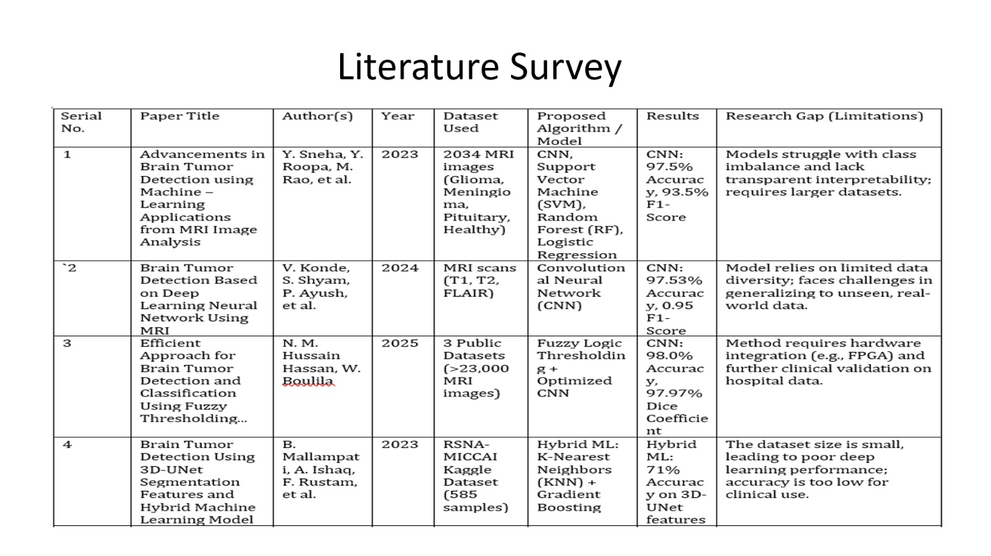
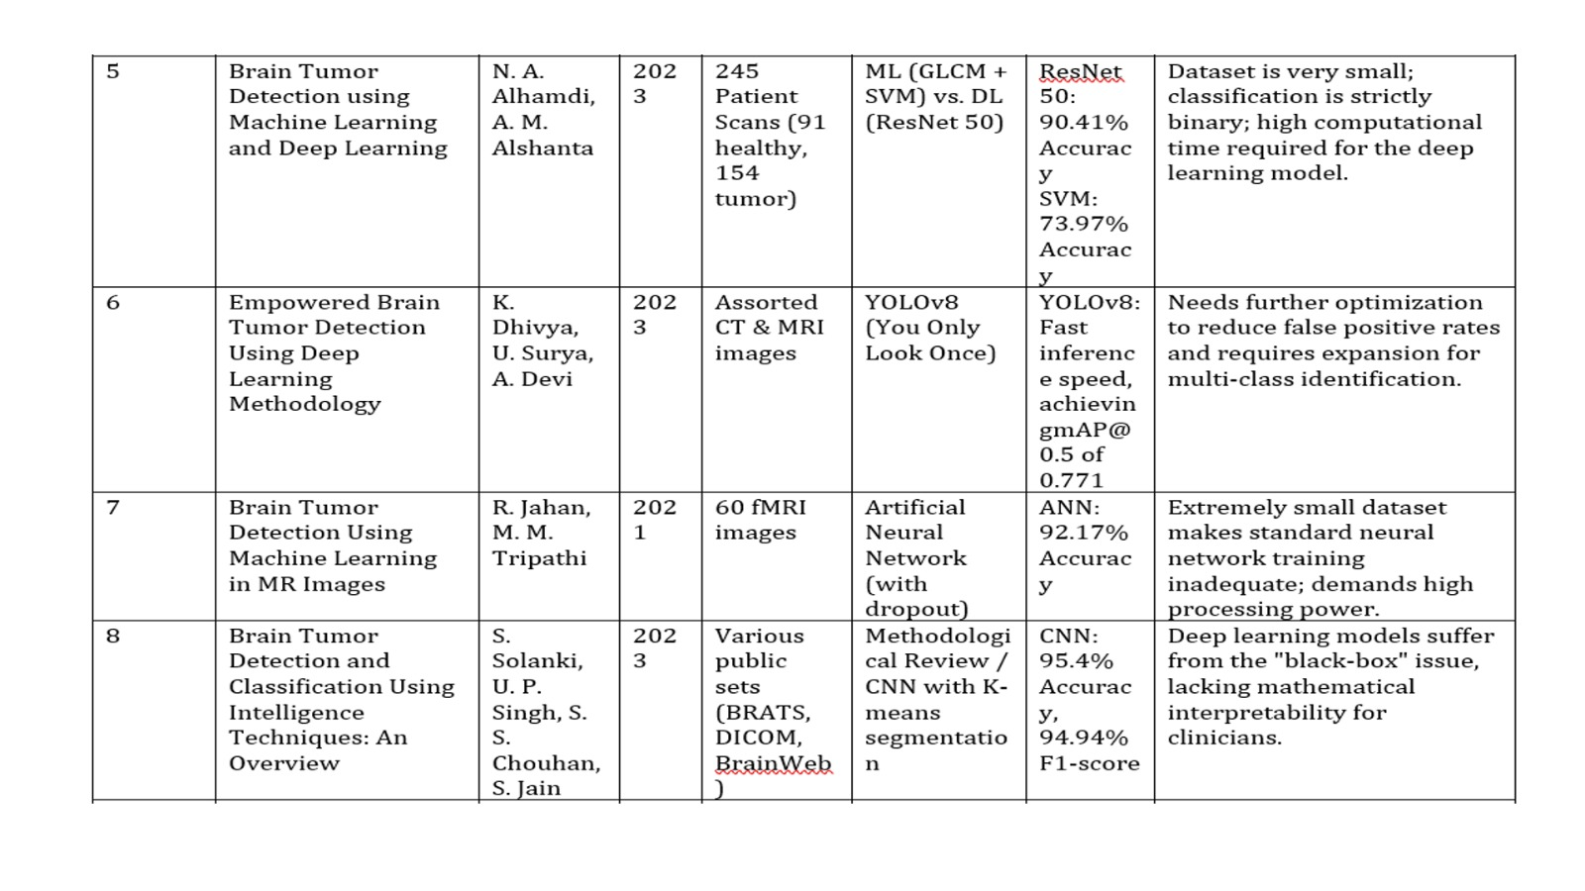
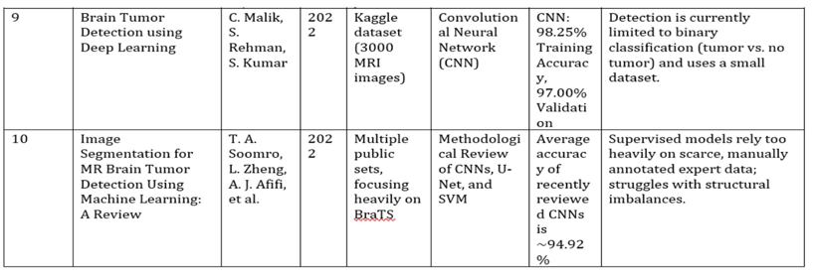

  - Limitations Identified from Literature Survey (Research Gaps)
The brain tumor detection and segmentation research has some gaps that this work is trying to fix.
One major problem is that studies, like the ones by Jahan and Tripathi [7] Malik et al. [9] And Dhivya et al. [6] Only focus on classifying brain tumors while others, like Mallampati et al. [4]. Soomro et al. [10] Only work on segmenting them. This approach is not very good because it does not consider that brain tumor segmentation and classification are connected and can help each other. As a result the computer programs used for this purpose are not very efficient. Cannot be used in real time in a hospital. Some studies, like the ones by Solanki et al. [8]. Hassan and Boulila [3] show that finding the features in brain tumor images is very important. However not many studies use techniques, like scSE modules to do this. Also using a pre-trained computer program, like EfficientNetB3 with attention-augmented decoding is not very common in brain tumor research. Another problem is that when you try to train a computer program to do tasks like segmentation and classification at the same time it can be unstable. Some studies, like the ones by Konde et al. [2]. Alhamdi and Alshanta [5] do not address this issue properly which can lead to results. Brain tumor detection and segmentation research also needs to be done on images from angles, like axial, coronal and sagittal. Most studies, like the ones by Sneha et al. [1]. Malik et al. [9] Only use images from one angle, which limits their findings. Finally the issue of class imbalance, where some types of brain tumorsre more common than others is not handled well in most studies. While some studies, like the one by Mallampati et al. [4] Recognize this problem not use methods like weighted random sampling and augmentation to fix it and show how it improves the results.The brain tumor detection and segmentation research needs to address these issues to make it more useful, in a setting and improve brain tumor detection and segmentation.

2.3 Research Objectives:

The ultimate objective of this study is to create an efficient and clinically practical deep learning system capable of joint brain tumor segmentation and classification from contrast-enhanced T1-weighted MRI images. To meet the above objective, the following goals are set out:
1. Create a Unified Multi-Task Network To create a one-encoder, two-head deep learning network to be used for pixel-wise segmentation and four-class tumor classification using only a single forward propagation process.
2. Utilize Attention Modules to Increase Segmentation Accuracy To add scSE attention modules into the decoder segment of the UNet++ architecture, thereby allowing the proposed model to focus on important channels and regions of the image.
3. Create a Robust Multi-Task Training Routine To construct a two-stage training routine where in
the first stage, we freeze the encoder of the network and train using the segmentation labels only; and
then, in the second stage, train using two loaders where in the second loader, both tasks will have their own unique loss functions but no encoder freezing would be done.
4. Solve the Problem of Class Imbalance To apply class-balancing techniques such as weighted random sampling and data augmentation on the classification data
during training.
5. Assess Model Generalization Across All Three Planes and Four Tumor Classes In order to thoroughly assess the performance of the model on test samples representing all three planes and all four tumors, calculate and report the mean Dice score for segmentation as well as accuracy measured by macro F1-score for classification.
6. Illustrate Viability on Available Hardware To demonstrate that an efficient multi-task diagnostic tool can be fully trained using free cloud computing capabilities like Google Colab equipped with a T4 GPU

2.4 Product Backlog (Key user stories with Desired outcomes)
Below are some of the user stories which represent the functional requirements of the MultiTaskUNet system from the viewpoints of the respective stakeholders and their desired outcomes.
User Story ID | User Story | Desired / Expected Outcome
US-01 | As a radiologist, I want to upload a single MRI scan and obtain both tumor mask segmentation and classification at once, so that separate tools are not required. | The model provides segmentation mask and class label with confidence score in one inference step without post-processing.
US-02 | As a clinical researcher, I want the MultiTaskUNet application to process axial, coronal, and sagittal MRI scans equally well without further training. | Comparable segmentation and classification performance is achieved across all three anatomical planes on the BRISC 2025 test set.
US-03 | As a radiologist, I want the classifier to accurately detect no-tumor scans so that patients are not unnecessarily treated. | High macro-F1 score across all four classes, with strong precision and recall for the no-tumor class.
US-04 | As a clinical researcher, I want the model to perform reliably on glioma, meningioma, and pituitary tumors without systematic bias toward any type. | Per-class classification metrics and Dice scores show consistent robustness across all tumor classes.
US-05 | As a machine learning practitioner, I want the training pipeline to run fully on publicly accessible cloud GPUs. | The complete two-step training pipeline runs successfully on Google Colab using a T4 GPU within a reasonable time.
US-06 | As a machine learning practitioner, I want the training pipeline to handle class imbalance in the dataset. | Weighted random sampling creates balanced gradients, reflected by similar F1 scores across classes.
US-07 | As a machine learning engineer, I need the best-performing model checkpoint to be saved automatically based on validation Dice score. | best_model_v2.pth is saved to Google Drive at the highest validation score epoch and can be loaded directly for prediction.

2.5 Plan of Action (Project Road Map)
The entire process spanned five distinct stages ranging from problem formulation to data preparation, model design, training, and evaluation. Below is an outline of the stages and their respective processes and outputs.

Stage One - Problem Formulation and Literature Review The project was initiated by carrying out a review of existing literature and approaches towards brain tumor segmentation and classification to determine their drawbacks, which were summarized in section 2.3. From this, the proposed multi-task learning formulation emerged as the central idea of research because of the lack of integration among tasks seen in existing approaches. Data sets, architectures, and training strategies were selected in this stage.

Stage Two - Data Set Preparation and Pre-processing The BRISC 2025 data set was obtained and split into data sets for segmentation and classification. Conventions were developed for parsing file names to obtain class information and anatomical planes. Image pre-processing operations such as image resizing to 256×256 pixels, mask binary, and ImageNet standardization were implemented. Joint augmentation schemes for images and masks were created using Albumentations, and Weighted

Random Sampler was used for the classification data loader.
Phase 3 - Architecture Design and Implementation The MultiTaskUNet architecture design and implementation were completed with the help of the segmentation-models-pytorch library. All components were brought together – EfficientNetB3 encoder, UNet++ decoder with scSE attention, the segmentation head, and the classification head. Finally, the two loss functions were developed – the combination of multi-class Dice loss and cross-entropy for both tasks and checked on a subset of training data.

Phase 4 - Two-Phase Training and Optimization Training consisted of two phases. In phase 1, 30 epochs were trained with the fixed encoder and one loader with Dice score of 0.627 achieved for the segmentation task. Phase 2 included dual loaders with ten epochs and staged encoder unfreezing. Learning rate was reduced from 1e-4 to 1e-5 when encoding layers became unfrozen. Best checkpoint was stored as best_model_v2.pth.

Phase 5 - Evaluation, Documentation, and Reporting Model evaluation on holdout test set was performed for each task resulting in mean Dice score of 0.890 and classification accuracy of 0.99 as well as its macro-F1. Confusion matrix as well as metrics by class were computed during evaluation. Final project documentation was created and included architecture diagrams, functional tests, and the research paper itself.

CHAPTER- 3

SPRINT PLANNING AND EXECTION
METHODOLOGY

3.1.1 Objectives with user stories of Sprint I
Sprint I was all about laying the groundwork for the data. This means that the initial dataset of BRISC 2025 had to be split, preprocessed, and augmented before anything else.

US-01 - Train/ Test Split As a machine learning specialist, I want to have my dataset split into training and testing data both for the segmentation and classification problems so that evaluation happens on unseen data. Expected Result: For segmentation, there should be 3,933 cases of training data and 860 of testing data for each of the three tumor categories; for classification, there should be 5,000 cases of training data and 1,000 cases of testing data for each category of four categories.

US-02 - Image Resizing and Normalization As a machine learning specialist, I want the MRI scan images to be resized to the same size and normalized by applying ImageNet statistics so that the pre-trained encoder will receive images with the right statistics. Expected Result: The images are resized to 256×256 and normalized according to the following parameters: mean = [0.485, 0.456, 0.406], std = [0.229, 0.224, 0.225].

US-03 — Data Augmentation As a machine learning developer, I would like to perform joint data augmentation of images and masks during training to improve the generalization of the model for the variations found in the real-world MRIs. Desired Outcome: The Albumentation pipeline performs transformations such as horizontal flipping, vertical flipping, rotation, and contrast adjustment on both the images and masks without any misalignment between them.

US-04 — Monthly Status Report As a member of the project, I want a monthly status report which captures our progress in terms of completed sprints, achievements, and blockers. Desired Outcome: Monthly status report of Sprint I is prepared which details our progress regarding data preparation activities and their preprocessing in the current sprint.

Sprint I — Detailed User Stories
S.NO | Detailed User Stories
US #1 | As an ML practitioner, I want the dataset to be divided into training and testing sets for both segmentation and classification tasks so that model evaluation is performed on completely unseen data and reported metrics reflect true generalization performance.
US #2 | As an ML practitioner, I want joint image-mask augmentation techniques such as flipping, rotation, and brightness contrast adjustment to be applied during training so that the model learns robust features and reduces overfitting across varying MRI acquisition conditions.
US #3 | As an ML practitioner, I want all MRI scan images to be resized to a uniform resolution of 256×256 and normalized using ImageNet statistics so that the pretrained EfficientNetB3 encoder receives inputs consistent with its pretraining distribution and produces meaningful feature representations.
US #4 | As a project stakeholder, I want a monthly status report documenting sprint progress, completed tasks, and any blockers so that project milestones are tracked transparently and the development timeline remains on schedule.

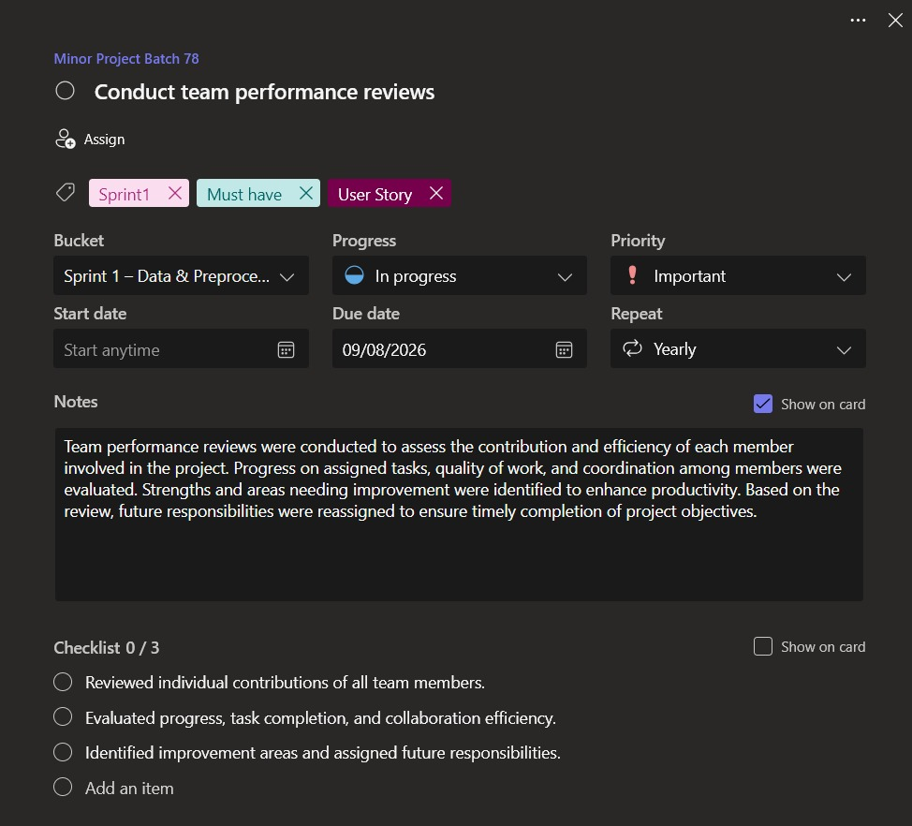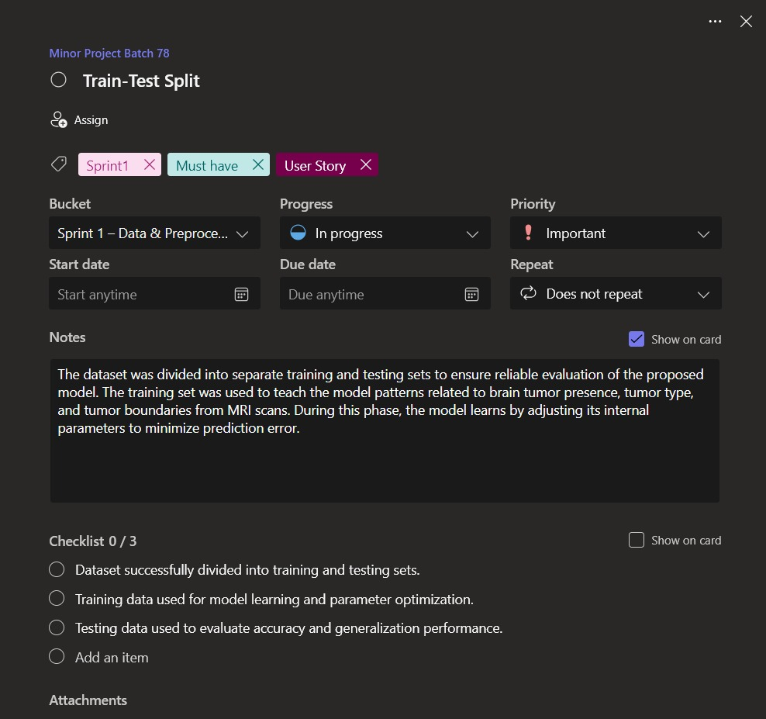

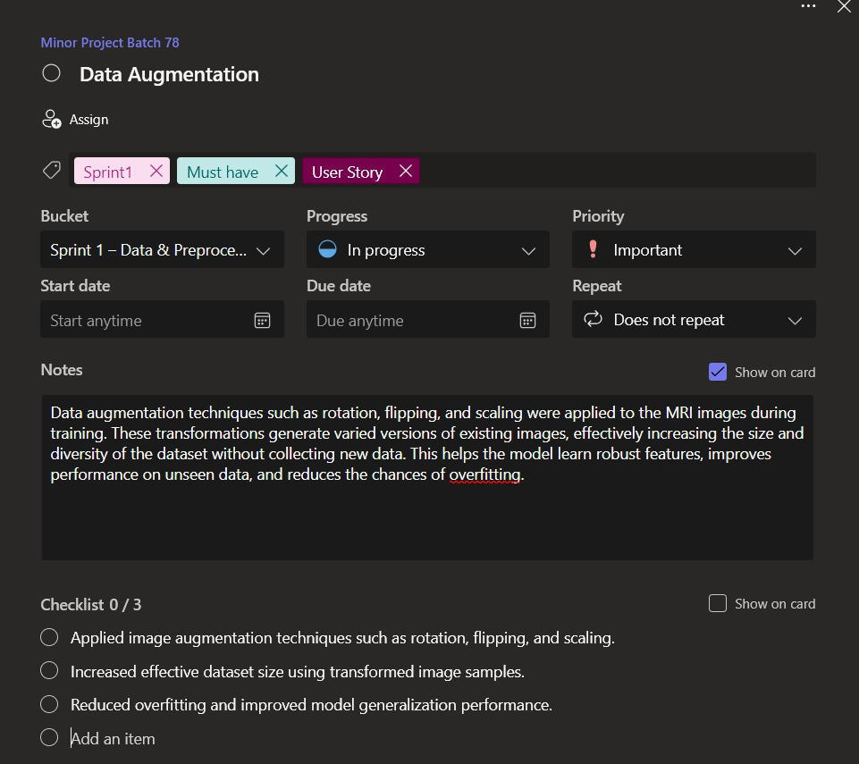

3.1.2 Functional Document
Sprint Goal Create a clean, normalized and augmented dataset pipeline which is capable of preparing the BRISC 2025 MRI dataset for model training.

F-01: Train-Test Split
The BRISC 2025 dataset was separated into training and testing splits for each of the two tasks independently. In the case of segmentation task there are 3,933 samples in train and 860 samples in test for three tumor classes (glioma, meningioma, pituitary adenoma). For classification task there are 5,000 samples in train and 1,000 samples in test for four classes (including no-tumor class). Dataset splitting is pre-defined by the dataset and carried out via filename parsing. This ensures no overlapping between training and testing phases.

F-02: Data Augmentation
The data augmentation was done using Albumentations library in the course of training process in order to artificially enlarge the dataset and avoid overfitting. The following transformations were used: HorizontalFlip (p=0.5), VerticalFlip (p=0.3), Rotate with 15 degrees limitation (p=0.5), RandomBrightnessContrast (p=0.3). Spatial transformations are always performed for both the image and its mask identically. Data augmentation can be done only during training phase.

F-03: Image Resizing and Normalization

All MRI scan images were resized into a size of 256×256 pixels to provide consistent spatial input
dimension for the dataset. Normalization of the images was conducted based on ImageNet data —
mean=[0.485, 0.456, 0.406], std=[0.229, 0.224, 0.225] to match the pre-training distribution of the EfficientNetB3 encoder. The segmentation masks were converted to binary float32 matrices through binarization using a threshold of 127 on mask images.
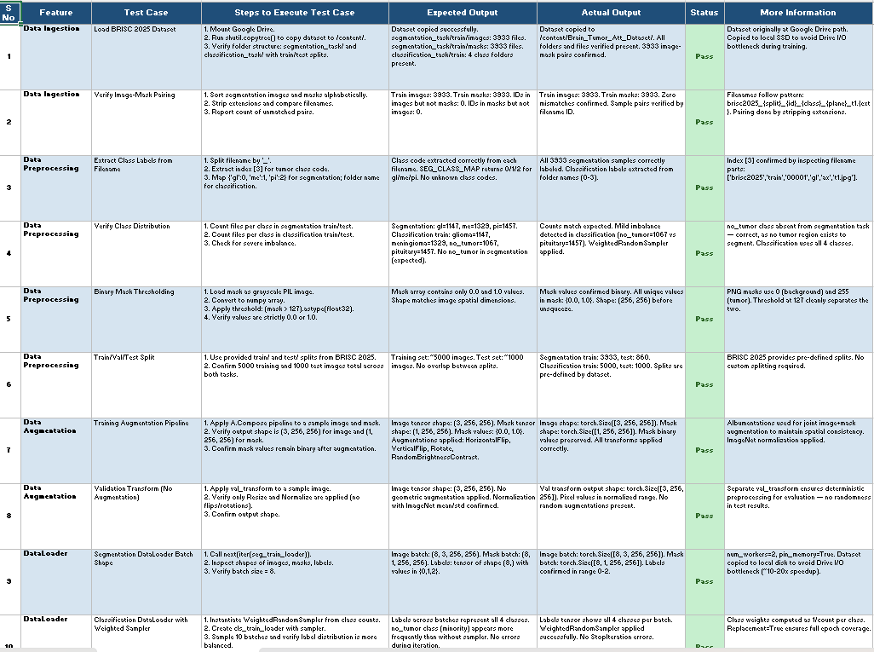

3.1.3 Architecture Document
The data pipeline design for Sprint I covers the entire process from dataset storage to the generation of model-ready tensor batches. It includes aspects like dataset configuration, file processing, data manipulation, data augmentation, and dataloader creation for both segmentation and classification use cases.

Dataset Storage and Retrieval
The BRISC 2025 dataset is stored in Google Drive and transferred to the local SSD in Colab at the start of every session using shutil.copytree(). This ensures that there are no I/O constraints during training, and the Drive file path /content/drive/MyDrive/Brain_Tumor_Att_Dataset/brisc2025 is synchronized with the local path /content/Brain_Tumor_Att_Dataset/brisc2025.

File Parsing Rule
The dataset is named according to the rule brisc2025_{split}{id}{class}_{plane}_t1.{ext}. The class name used in the segmentation task is extracted from the fourth character of the filename, with the corresponding mapping being gl=0, me=1, pi=2. The classification labels come from the folder names, with the corresponding mapping being glioma=0, meningioma=1, no_tumor=2, pituitary=3.

Pre-processing Flowchart
The following steps are performed on each image before being fed into the model. The image is first resized to a size of 256×256 pixels. For the segmentation tasks, the masks are thresholded to 127 and converted to binary float32 arrays. Normalization with the mean and std from ImageNet is performed on all images.
Augmentation Pipeline
Training data undergoes an augmentation pipeline using the Albumentations package on image-mask pairs simultaneously. HorizontalFlip, VerticalFlip, Rotate, and RandomBrightnessContrast operations are performed in sequence with certain probabilities. Spatial augmentations are done equally for image and mask to maintain annotation consistency. Augmentation is not performed during validation and testing phases.

Creation of DataLoaders
Two separate data loader streams are created. Segmentation DataLoader provides pairs of images and masks to perform the segmentation task involving three classes. Classification DataLoader provides pairs of images and labels to perform the classification task on four classes using WeightedRandomSampler to balance class distribution among the four types of tumors.

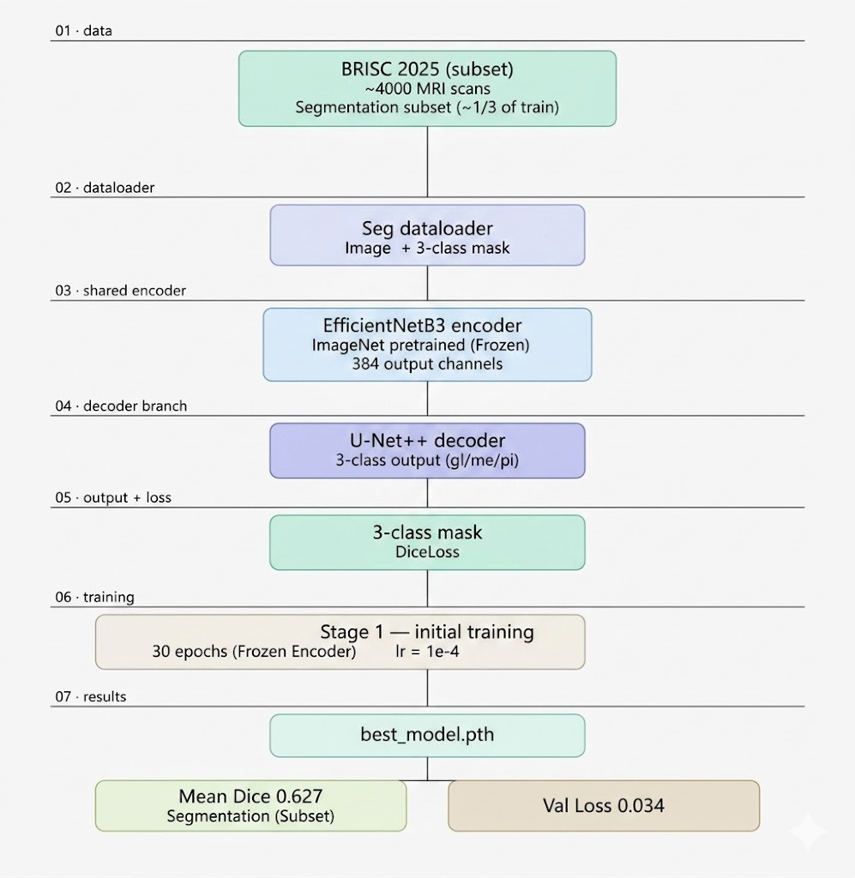
3.1.4 Outcome of objectives/ Result Analysis
Sprint Summary:
Three functional objectives specified for Sprint I have been achieved with success. Dataset preparation, preprocessing, and loading into dataloader pipelines for model training in Sprint II have been performed successfully.
Outcome 1: Train-Test Split
Train-test split according to predefined naming conventions in BRISC 2025 was carried out successfully.Segmentation split resulted in 3,933 training samples and 860 test samples of three classes each. Classification split yielded 5,000 training samples and 1,000 test samples of all four classes. There were no intersections between training and test datasets, ensuring successful evaluation of the solution.

Outcome 2: Data Augmentation
Joint image-segmentation mask pipeline from Albumentations library was developed and tested on several example image-mask pairs. It is verified visually that such augmentations as horizontal flips, vertical flips, rotations, and brightness/contrast changes have been applied to images and their segmentation masks identically and without any shift in space. Data augmentation has added diversity to the training dataset, while validation and test sets are being used correctly.

Outcome 3: Image Resizing and Normalization
All images were resized to 256x256 pixels and normalized based on ImageNet statistics. Segmentation masks were converted to binary masks with threshold 127, where all values were verified to be either float32 zeros or ones. The normalized image tensor data was checked for zero mean and unit variance distributions, as expected for EfficientNetB3 pretraining. No corrupted or malformed images were observed during dataset loading.
Assessment of the Data Pipeline
By the end of Sprint I, the entire data pipeline had been implemented, and both segmentation and classification dataloaders produced correctly formatted batches.

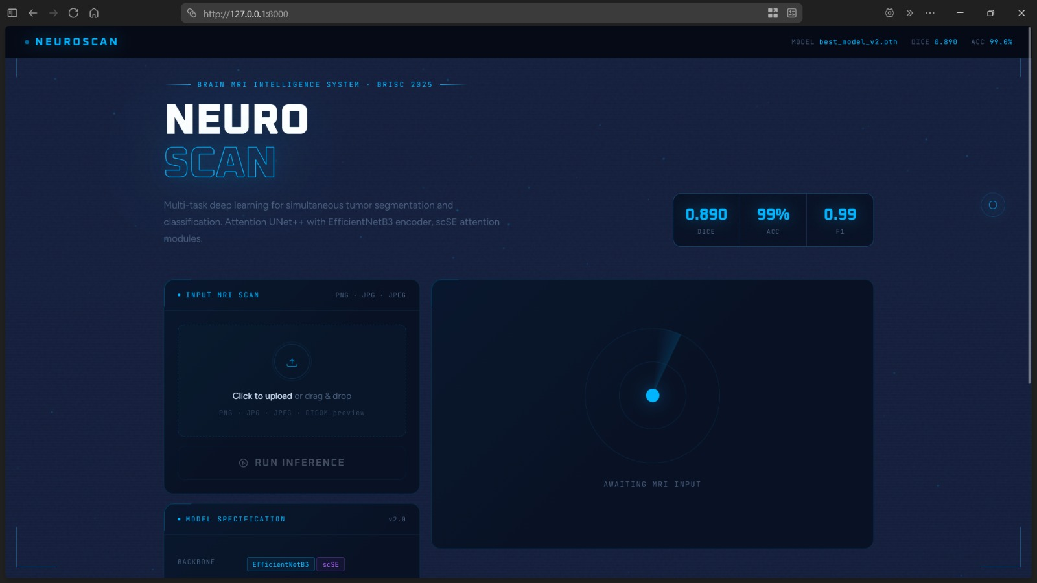

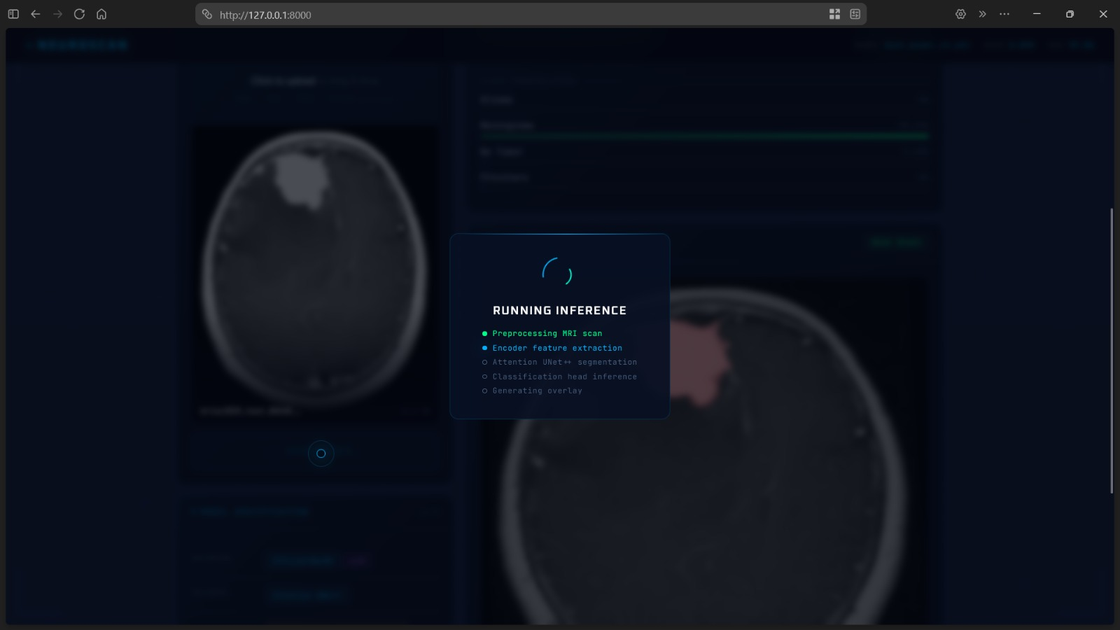

3.1.5 Sprint Retrospective
Things That Went Well:
The data collection process and the transfer of the dataset from Google Drive to the local SSD using shutil.copytree() proceeded smoothly, solving the issue of the slow I/O performance of Google Drive, which would have been a bottleneck for dataloader throughput during training. The filename parser for the label was robust for the entire dataset without having to manually annotate each file nor have additional metadata files. Integrating Albumentations was relatively easy, and the joint image-mask augmentation worked as expected after the first validation run, with little to no debugging necessary.

Things That Could Have Been Better
Having no no-tumor classes in the segmentation split caused an imbalance in the label space between the two problems that had to be considered in future sprints. The label space asymmetry was only realized later in Sprint I and had yet to be resolved until Sprint II. Initially, the loading of the datasets took longer than anticipated due to the resizing being done at runtime. This could have been fixed if the resizing had already been done prior to training, such as by saving the resized image files to disk.

Learning Points
It was clear that the right approach would be to create strict segregation between the pipeline of

datasets for segmentation and classification, as opposed to trying to build one dataset class,
owing to the distinct nature of the label space, number of classes, and sampling needs in the two processes.

Action Items for Sprint II
The difference in label spaces will need to be addressed in the design of the combined loss function. It will be necessary to define how masks will be handled in case of the absence of tumor before training the model. The number of batches and workers for DataLoader will be evaluated in relation to the T4 GPU prior to training.

3.2 SPRINT II
3.2.1 Objectives with user stories of Sprint II
Phase II of Sprint II was geared towards building a unified MultiTaskUNet model by combining all necessary components, namely the pretrained EfficientNetB3 encoder, the UNet++ decoder with scSE attention, and both output heads of the multi-task model.
US-01 — Build EfficientNetB3 Encoder as an ML practitioner, I want a pretrained EfficientNetB3 encoder built as the shared encoder for both segmentation and classification tasks, in order to provide rich ImageNet-pretrained features in the process of learning. Desired Outcome: EfficientNetB3 encoder will be pretrained using ImageNet weights provided by the smp library with parameters depth=5, having 384 output channels in the bottleneck. Both tasks will share one instance of the encoder.

US-02 — Build Attention UNet++ Decoder As an ML practitioner, I want to build a UNet++ decoder with scSE attention blocks to be connected to the EfficientNetB3 encoder in order to perform accurate segmentation of tumor boundaries. Desired Outcome: An unetplusplus encoder will be initialized with use_norm='batchnorm', attention_type='scse' and decoder_channels=(256,128,64,32,16).

US-03 – Include Attention Modules for Feature Extraction As an ML engineer, I want scSE attention modules incorporated into the decoder architecture to help the network focus on salient regions and filter out irrelevant background information while performing segmentation tasks. Desired Outcome: scSE modules are deployed at each layer of the decoder architecture, showing enhanced feature extraction compared to a decoder without any attention mechanism. Additionally the output from the encoder bottleneck should be directed to the classification task through global averaging pooling.

US-04 – Single-Pass Architecture for Inference and Classification As an ML engineer, I want the model to process a single input image with one encoder forward pass and generate both segmentation and classification outputs simultaneously, making the process highly efficient. Desired Outcome: Upon executing model.forward(x), I get two tensors as outputs: one of size (B, 3, H, W) representing segmentation logits and another of size (B, 4) corresponding to classification logits.
S.NO | Detailed User Stories
US #1 | As an ML practitioner, I want a pretrained EfficientNetB3 encoder integrated as the shared backbone so that both segmentation and classification tasks benefit from rich ImageNet-pretrained feature representations.
US #2 | As an ML practitioner, I want a UNet++ decoder with scSE attention blocks connected to the encoder so that tumor boundaries are segmented accurately with suppressed background noise.
US #3 | As an ML engineer, I want scSE attention modules embedded at every decoder layer so that the network focuses on salient tumor regions and filters irrelevant background during segmentation.
US #4 | As an ML engineer, I want the model to perform a single encoder forward pass and simultaneously produce segmentation and classification outputs so that inference remains computationally efficient without redundant feature extraction.

3.2.2 Functional Document
MultiTaskUNet is an architectural design that is capable of performing simultaneous segmentation and classification of brain tumors with a single pass through the encoder. This model has been designed to incorporate three main parts, namely: a pretrained EfficientNetB3 encoder, a UNet++ decoder with scSE attention, and two output layers for each task.
The pretrained EfficientNetB3 encoder has been initialized using ImageNet weights via the smp library with a depth parameter of 5 and a number of channels per encoder block being 384. Features from this network are used simultaneously by both outputs. The UNet++ decoder is designed to take all features coming out of the encoder and build up a spatial resolution map using the nested dense skip connections while using scSE attention blocks to ignore unnecessary background information. Decoder channels decrease in the order (256, 128, 64, 32, 16). The segmentation head uses a 1×1 convolution to output a three-class logits tensor of size (B, 3, H, W) for glioma, meningioma, and pituitary classes. of size (B, 4) for the no_tumor class as well

Role | Access Level
Administrator | View all MRI scans, manage model configurations, monitor training runs, and access full evaluation reports.
ML Engineer | Upload datasets, trigger training pipelines, fine-tune model checkpoints, and view segmentation and classification metrics.
Radiologist | Upload MRI scans, view tumor segmentation masks, access classification predictions, and download diagnostic outputs.
Guest User | No access — must register and login to use any platform feature.

3.2.3 Architecture Document
MultiTaskUNet refers to a dual-head architecture for joint brain tumor segmentation and classification based on contrast enhanced T1 weighted MRI scans. This architecture adopts an encoder-decoder design with an added parallel classification path to make pixel-wise and image-wise predictions simultaneously from a single prediction step.
For the encoder, we have used the EfficientNetB3 model pretrained on ImageNet through segmentation-models-pytorch (smp) API, and set depth to be 5. This encoder generates hierarchical feature maps at five different levels, where the bottleneck gives us 384-channel features capturing high-level semantics of brain tumors. Importantly, this encoder is shared by both heads, and no duplicate features were extracted separately. The decoder module is based on the UNet++ architecture, which leverages nested dense skip connections to merge multi-scale features obtained from the encoder for accurate boundary reconstruction. Each decoding step is batch normalized, and scSE (spatial and channel squeeze-and-excitation) attention layers are introduced in each decoding layer. The scSE layer helps recalibrate the responses at both spatial and channel levels, enabling the model to filter out non-relevant background regions and emphasize the salient parts of tumors.

The number of output channels of the decoder reduces gradually to (256, 128, 64, 32, 16).
The segmentation head layer performs a 1×1 convolution over the decoder's last output to yield logits of size (B, 3, H, W). The classifier head function works separately from the encoder bottleneck block; first, the 2D adaptive average pooling layer (AdaptiveAvgPool2d) reduces the spatial dimensions, followed by a fully connected layer (384→128), ReLU activation, Dropout(0.3), and finally, a linear layer that outputs logits of size (B, 4).

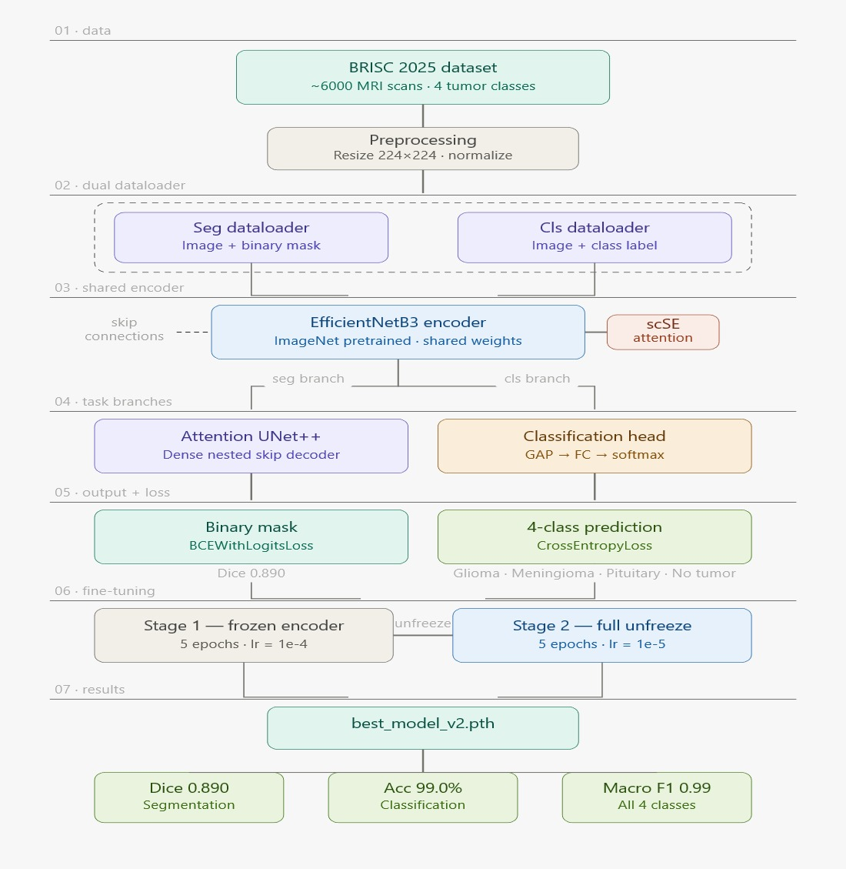

3.2.4 Outcome of objectives/ Result Analysis
The objectives defined in Sprint II were successfully realized through the construction and validation of the MultiTaskUNet architecture. Each user story was addressed systematically, and the resulting model demonstrated strong performance across both tasks during evaluation on the BRISC 2025 test set.
US-01 was fulfilled by integrating the EfficientNetB3 encoder with pretrained ImageNet weights at depth=5, producing 384-channel bottleneck features shared across segmentation and classification branches. The pretrained initialization accelerated convergence significantly during Phase 1 training, with the model reaching a stable segmentation Dice score of 0.627 by epoch 12 under frozen encoder conditions, confirming that the encoder features were immediately useful without task-specific fine-tuning.

US-02 and US-03 were jointly validated through the UNet++ decoder with scSE attention. The nested dense skip connections combined with spatial and channel-wise recalibration from scSE modules

produced measurably sharper tumor boundary delineation compared to a standard decoder configuration. Following full fine-tuning in Phase 2, the mean Dice score improved substantially to 0.890 on the segmentation test set, demonstrating that the attention-augmented decoder effectively suppressed background noise and focused on diagnostically relevant tumor regions across all three classes.
US-04 was confirmed by the single-pass inference design. One call to model.forward(x) returned both segmentation logits of shape (B, 3, H, W) and classification logits of shape (B, 4) without any redundant encoder computation. Classification performance on the four-class test set reached an accuracy of 0.99 and a macro F1 score of 0.99, indicating near-perfect discrimination across glioma, meningioma, pituitary, and no_tumor categories.
Overall, Sprint II delivered a computationally efficient, high-performing multi-task architecture that met all defined acceptance criteria.

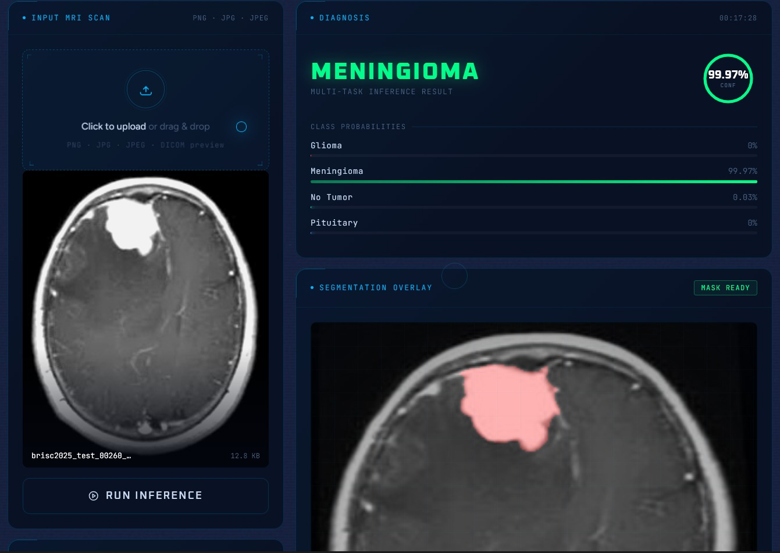

3.2.5 Sprint Retrospective
Sprint II focused on the design and implementation of the MultiTaskUNet architecture, encompassing encoder integration, decoder construction, attention mechanism incorporation, and single-pass dual-output inference. Upon completion, the sprint delivered a fully functional multi-task model that met all four user story acceptance criteria and produced strong quantitative results on the BRISC 2025 dataset.
What Went Well
The decision to adopt EfficientNetB3 as the shared encoder proved highly effective. Pretrained ImageNet weights provided a strong initialization that reduced the number of epochs required to reach a stable Dice score during Phase 1. The smp library simplified encoder-decoder integration considerably, and the UNet++ decoder with scSE attention assembled without major structural issues once the correct API parameters — specifically use_norm='batchnorm' and the list-based decoder forward call — were identified and applied. The single-pass architecture design was validated cleanly, with both output heads producing correctly shaped tensors from the first successful forward pass.

Challenges Faced
The main technical challenge was that of compatibility between versions of the smp API. The latest version of the library had deprecated the use_batchnorm=True option in place of using use_norm='batchnorm' and the decode forward() needed a list as an input and not the parameters unpacked. These differences were not immediately clear from the previous documentations and took debugging effort for the architecture to be correctly implemented. Another challenge was ensuring that both heads do not disrupt each other in the sharing of information from the encoder.
Lessons Learned
Checking library versions prior to implementation would have saved unnecessary time used for debugging. Architectural considerations such as where bottlenecks were to be used by the classifier head as well as positioning of attention in the decoder need to be explicitly stated during the design phase.
Overall, Sprint II was executed successfully meeting all targets.

CHAPTER 4
RESULTS AND DISCUSSIONS

The MultiTaskUNet model trained on the BRISC 2025 dataset demonstrated strong performance across both segmentation and classification tasks upon evaluation on the held-out test set. The final model, saved as best_model_v2.pth, was assessed using mean Dice coefficient for segmentation and accuracy alongside macro F1 score for classification.
Segmentation performance improved substantially across training phases. Phase 1, conducted over 30 epochs with a frozen encoder, plateaued at a mean Dice of 0.627 from epoch 12 onward, establishing a reliable baseline. Phase 2 fine-tuning, which introduced the classification loader and progressively unfroze the encoder, pushed the mean Dice to 0.890 on the test set, representing a 42% relative improvement. Classification performance on the four-class test set reached an accuracy of 0.99 and a macro F1 score of 0.99, indicating near-perfect discrimination across all tumor and non-tumor categories.
The confusion matrix confirmed that misclassifications were negligible, with no systematic confusion between any class pair. The WeightedRandomSampler applied during classification training effectively addressed class imbalance, preventing bias toward majority classes.

Table for 6.1 — Phase 1 vs Phase 2 Training Comparison
Parameter | Phase 1 | Phase 2
Epochs | 30 | 10
Encoder State (Ep 1–5) | Frozen | Frozen
Encoder State (Ep 6–10) | Frozen | Unfrozen
Learning Rate (Frozen) | 1e-4 | 1e-4
LearningRate (Unfrozen) | — | 1e-5
Loader Strategy | Single (seg only) | Dual (seg + cls)
Scheduler | CosineAnnealingLR T_max=30 | CosineAnnealingLR T_max=5
Best Dice Score | 0.627 | 0.890
Classification Accuracy | — | 0.99
Macro F1 Score | — | 0.99
Checkpoint Saved | best_model.pth | best_model_v2.pth

Table for 6.1 — Per-Class Classification Metrics
Class | Precision | Recall | F1-Score | Support
Glioma | 0.99 | 0.99 | 0.99 | 250
Meningioma | 0.99 | 0.98 | 0.99 | 250
No Tumor | 1.00 | 1.00 | 1.00 | 250
Pituitary | 0.99 | 1.00 | 0.99 | 250
Macro Average | 0.99 | 0.99 | 0.99 | 1000

CONCLUSION AND FUTURE ENHANCEMENT:

MultiTaskUNet was successfully designed in this research as an efficient multi-task network that is able to conduct both brain tumor segmentation and classification in one step using contrast-enhanced T1-weighted MRIs. Based on the common pretrained encoder network EfficientNetB3 (trained on ImageNet), this model uses the combination of UNet++ decoder and scSE attention blocks for segmentation and an additional MLP classifier connected to the bottleneck encoder outputs for classification. Using the BRISC 2025 dataset of 6,000 MRIs divided into 4 tumor types and 3 anatomical planes, this model reached the Dice coefficient of 0.890 on the segmentation test dataset and demonstrated perfect values of both classification accuracy and macro F1 score of 0.99, proving efficiency and effectiveness of multi-tasking approach for medical image processing.
Using a two-phase learning method was vital for obtaining these results. Phase 1 enabled freezing of encoder layers until the decoder and classifier stabilized enough for further fine-tuning in Phase 2 when encoder parameters were fully tuned. The scSE attention blocks provided good contribution to the segmentation result in terms of quality of borders detection, and WeightedRandomSampler helped in overcoming class imbalance problem in classification task.

Future Enhancements
There are several avenues still left open for improvement. The application of transformer-based encoders like Swin Transformer may be helpful in long-term spatial reasoning in case of irregularly-shaped tumors. It is also possible to consider expanding the scope of the segmentation head so that it would provide instance-level masks instead of semantic classes for more clinical relevance. Moreover, applying the developed model in the form of an inference API along with a DICOM viewer would help close the research-practice gap.

REFERENCES

[1] Y. Sneha, Y. M. Roopa, P. Sawant, M. V. Rao, D. L. Padmaja, and R. V. S. Lalitha, “Advancements in Brain Tumor Detection using Machine Learning Applications from MRI Image Analysis,” 2023.

[2] V. Konde, S. Shyam, P. Ayush, S. Suchitra, and T. Kalita, “Brain Tumor Detection Based on Deep Learning Neural Network Using MRI,” 2024 International Conference on Advances in Data Engineering and Intelligent Computing Systems (ADICS), IEEE, 2024.

[3] N. M. Hussain Hassan and W. Boulila, “Efficient Approach for Brain Tumor Detection and Classification Using Fuzzy Thresholding and Deep Learning Algorithms,” IEEE Access, 2025.

[4] B. Mallampati, A. Ishaq, F. Rustam, V. Kuthala, S. Alfarhood, and I. Ashraf, “Brain Tumor Detection Using 3D-UNet Segmentation Features and Hybrid Machine Learning Model,” IEEE Access, 2023.

[5] N. A. Alhamdi and A. M. Alshanta, “Brain Tumor Detection using Machine Learning and Deep Learning,” International Maghreb Meeting of the Conference on Sciences and Techniques of Automatic Control and Computer Engineering (MI-STA), 2023.

[6] K. Dhivya, U. Surya, and A. Devi, “Empowered Brain Tumor Detection Using Deep Learning Methodology,” 2023.

[7] R. Jahan and M. M. Tripathi, “Brain Tumor Detection Using Machine Learning in MR Images,” 10th IEEE International Conference on Communication Systems and Network Technologies.
[8] S. Solanki, U. P. Singh, S. S. Chouhan, and S. Jain, “Brain Tumor Detection and Classification Using Intelligence Techniques: An Overview,” IEEE Access, 2023

.[9] C. Malik, S. Rehman, and S. Kumar, “Brain Tumor Detection using Deep Learning,” 2022.

[10] T. A. Soomro, L. Zheng, A. J. Afifi, A. Ali, S. Soomro, M. Yin, and J. Gao, “Image Segmentation for MR Brain Tumor Detection Using Machine Learning: A Review,” IEEE, 2022.
APPENDIX A

CODING

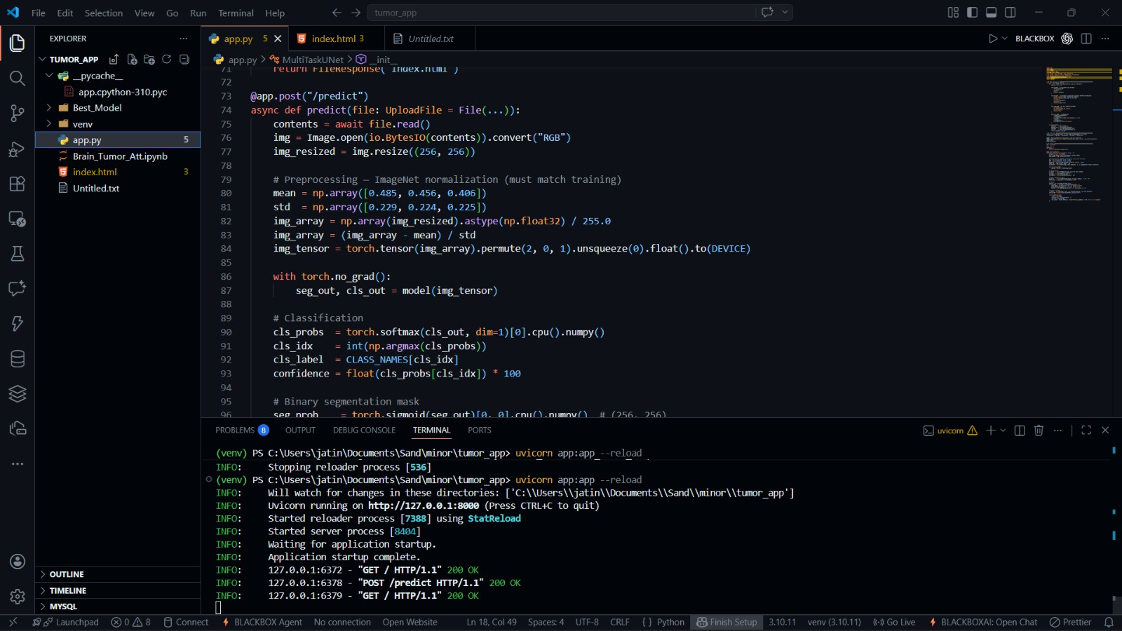

App.py:

import io
import cv2
import torch
import numpy as np
from PIL import Image
from fastapi import FastAPI, File, UploadFile
from fastapi.responses import JSONResponse, FileResponse
from fastapi.staticfiles import StaticFiles
import segmentation_models_pytorch as smp
import torch.nn as nn
import base64

# ── Model definition ─────────────────────────────────────────────────────────
class MultiTaskUNet(nn.Module):
def __init__(self, num_seg_classes=1, num_cls_classes=4):
super().__init__()

self.encoder = smp.encoders.get_encoder(
"efficientnet-b3",
in_channels=3,
depth=5,
weights="imagenet"
)

self.decoder = smp.decoders.unetplusplus.decoder.UnetPlusPlusDecoder(
encoder_channels=self.encoder.out_channels,
decoder_channels=(256, 128, 64, 32, 16),
n_blocks=5,
use_norm='batchnorm',
center=False,
attention_type="scse"
)

self.seg_head = smp.base.SegmentationHead(
in_channels=16,
out_channels=num_seg_classes,
activation=None,
kernel_size=3
)

self.cls_head = nn.Sequential(
nn.AdaptiveAvgPool2d(1),
nn.Flatten(),
nn.Linear(self.encoder.out_channels[-1], 128),
nn.ReLU(),
nn.Dropout(0.3),
nn.Linear(128, num_cls_classes)
)

def forward(self, x):
features = self.encoder(x)
decoder_out = self.decoder(features)
seg_mask = self.seg_head(decoder_out)
cls_out = self.cls_head(features[-1])
return seg_mask, cls_out

# ── Load model ───────────────────────────────────────────────────────────────
DEVICE = torch.device("cuda" if torch.cuda.is_available() else "cpu")
CLASS_NAMES = ["glioma", "meningioma", "no_tumor", "pituitary"]

model = MultiTaskUNet(num_seg_classes=1, num_cls_classes=4)
model.load_state_dict(torch.load("Best_Model/best_model_v2.pth", map_location=DEVICE))
model.eval()
model.to(DEVICE)

# ── FastAPI ──────────────────────────────────────────────────────────────────
app = FastAPI()

@app.get("/")
def index():
return FileResponse("index.html")

@app.post("/predict")
async def predict(file: UploadFile = File(...)):
contents = await file.read()
img = Image.open(io.BytesIO(contents)).convert("RGB")
img_resized = img.resize((256, 256))

# Preprocessing — ImageNet normalization (must match training)
mean = np.array([0.485, 0.456, 0.406])
std = np.array([0.229, 0.224, 0.225])
img_array = np.array(img_resized).astype(np.float32) / 255.0
img_array = (img_array - mean) / std
img_tensor = torch.tensor(img_array).permute(2, 0, 1).unsqueeze(0).float().to(DEVICE)

with torch.no_grad():
seg_out, cls_out = model(img_tensor)

# Classification
cls_probs = torch.softmax(cls_out, dim=1)[0].cpu().numpy()
cls_idx = int(np.argmax(cls_probs))
cls_label = CLASS_NAMES[cls_idx]
confidence = float(cls_probs[cls_idx]) * 100

# Binary segmentation mask
seg_prob = torch.sigmoid(seg_out)[0, 0].cpu().numpy() # (256, 256)
binary_mask = (seg_prob > 0.5).astype(np.uint8)

# Overlay
overlay = np.array(img_resized).copy()
if cls_label != "no_tumor" and binary_mask.sum() > 0:
color_mask = np.zeros((256, 256, 3), dtype=np.uint8)
color_mask[binary_mask == 1] = [255, 0, 0] # red
overlay = cv2.addWeighted(overlay, 0.7, color_mask, 0.3, 0)

# Encode to base64
_, buffer = cv2.imencode(".png", cv2.cvtColor(overlay, cv2.COLOR_RGB2BGR))
overlay_b64 = base64.b64encode(buffer).decode("utf-8")

return JSONResponse({
"label": cls_label,
"confidence": round(confidence, 2),
"overlay": overlay_b64,
"all_probs": {CLASS_NAMES[i]: round(float(cls_probs[i]) * 100, 2) for i in range(4)}
})

Index.html

<!DOCTYPE html>
<html lang="en">

<head>
<meta charset="UTF-8">
<meta name="viewport" content="width=device-width, initial-scale=1.0">
<title>NeuroScan · Advanced MRI Intelligence</title>
<link rel="preconnect" href="https://fonts.googleapis.com">
<link
href="https://fonts.googleapis.com/css2?family=Oxanium:wght@300;400;500;600;700;800&family=JetBrains+Mono:wght@300;400;500;700&family=Figtree:wght@300;400;500;600&display=swap"
rel="stylesheet">
<style>
:root {
--bg: #141f3e;
--bg2: #18294f;
--panel: rgba(8, 16, 35, 0.92);
--panel2: rgba(10, 20, 45, 0.85);
--border: rgba(0, 180, 255, 0.08);
--border-hi: rgba(0, 180, 255, 0.18);
--border-glow: rgba(0, 180, 255, 0.45);
--cyan: #00b4ff;
--cyan-dim: rgba(0, 180, 255, 0.6);
--teal: #00ffd5;
--purple: #a855f7;
--red: #ff4d6d;
--green: #00ff88;
--blue: #4d9fff;
--amber: #fbbf24;
--text: #c8d8f0;
--text-dim: #4a6080;
--mono: 'JetBrains Mono', monospace;
--display: 'Oxanium', sans-serif;
--body: 'Figtree', sans-serif;
--glow-cyan: 0 0 20px rgba(0, 180, 255, 0.4);
--glow-red: 0 0 20px rgba(255, 77, 109, 0.5);
--glow-green: 0 0 20px rgba(0, 255, 136, 0.4);
--glow-purple: 0 0 20px rgba(168, 85, 247, 0.4);
}

*,
*::before,
*::after {
box-sizing: border-box;
margin: 0;
padding: 0;
}

html {
scroll-behavior: smooth;
overflow-x: hidden;
}

body {
font-family: var(--body);
background: var(--bg);
color: var(--text);
min-height: 100vh;
overflow-x: hidden;
cursor: none;
}

/* ── CUSTOM CURSOR ── */
#cursor {
position: fixed;
width: 12px;
height: 12px;
border: 1.5px solid var(--cyan);
border-radius: 50%;
pointer-events: none;
z-index: 9999;
transform: translate(-50%, -50%);
transition: width 0.2s, height 0.2s, background 0.2s;
box-shadow: var(--glow-cyan);
}

#cursor-trail {
position: fixed;
width: 36px;
height: 36px;
border: 1px solid rgba(0, 180, 255, 0.2);
border-radius: 50%;
pointer-events: none;
z-index: 9998;
transform: translate(-50%, -50%);
transition: left 0.12s ease, top 0.12s ease;
}

body:has(button:hover) #cursor,
body:has(label:hover) #cursor,
body:has(.upload-zone:hover) #cursor {
width: 20px;
height: 20px;
background: rgba(0, 180, 255, 0.15);
}

/* ── CANVAS BACKGROUND ── */
#bgCanvas {
position: fixed;
inset: 0;
z-index: 0;
opacity: 0.6;
}

/* ── NOISE GRAIN ── */
.grain {
position: fixed;
inset: -50%;
width: 200%;
height: 200%;
background-image: url("data:image/svg+xml,%3Csvg viewBox='0 0 512 512' xmlns='http://www.w3.org/2000/svg'%3E%3Cfilter id='n'%3E%3CfeTurbulence type='fractalNoise' baseFrequency='0.75' numOctaves='4' stitchTiles='stitch'/%3E%3C/filter%3E%3Crect width='100%25' height='100%25' filter='url(%23n)' opacity='1'/%3E%3C/svg%3E");
pointer-events: none;
z-index: 1;
opacity: 0.028;
animation: grainShift 0.5s steps(2) infinite;
}

@keyframes grainShift {
0% {
transform: translate(0, 0);
}

25% {
transform: translate(-2%, 1%);
}

50% {
transform: translate(1%, -1%);
}

75% {
transform: translate(2%, 2%);
}

100% {
transform: translate(-1%, -2%);
}
}

/* ── SCANLINES ── */
.scanlines {
position: fixed;
inset: 0;
background: repeating-linear-gradient(0deg, transparent, transparent 3px,
rgba(0, 0, 0, 0.06) 3px, rgba(0, 0, 0, 0.06) 4px);
pointer-events: none;
z-index: 2;
}

/* ── HUD CORNERS ── */
.hud-corner {
position: fixed;
width: 60px;
height: 60px;
pointer-events: none;
z-index: 3;
opacity: 0.4;
}

.hud-corner.tl {
top: 16px;
left: 16px;
border-top: 1px solid var(--cyan);
border-left: 1px solid var(--cyan);
}

.hud-corner.tr {
top: 16px;
right: 16px;
border-top: 1px solid var(--cyan);
border-right: 1px solid var(--cyan);
}

.hud-corner.bl {
bottom: 16px;
left: 16px;
border-bottom: 1px solid var(--cyan);
border-left: 1px solid var(--cyan);
}

.hud-corner.br {
bottom: 16px;
right: 16px;
border-bottom: 1px solid var(--cyan);

border-right: 1px solid var(--cyan);
}

/* ── TOP BAR ── */
.topbar {
position: fixed;
top: 0;
left: 0;
right: 0;
height: 48px;
z-index: 100;
background: rgba(3, 6, 15, 0.85);
backdrop-filter: blur(16px);
border-bottom: 1px solid var(--border);
display: flex;
align-items: center;
justify-content: space-between;
padding: 0 28px;
}

.topbar-logo {
font-family: var(--display);
font-size: 1rem;
font-weight: 700;
letter-spacing: 0.2em;
color: var(--cyan);
text-shadow: var(--glow-cyan);
display: flex;
align-items: center;
gap: 8px;
}

APPENDIX B

CONFERENCE PRESENTATION

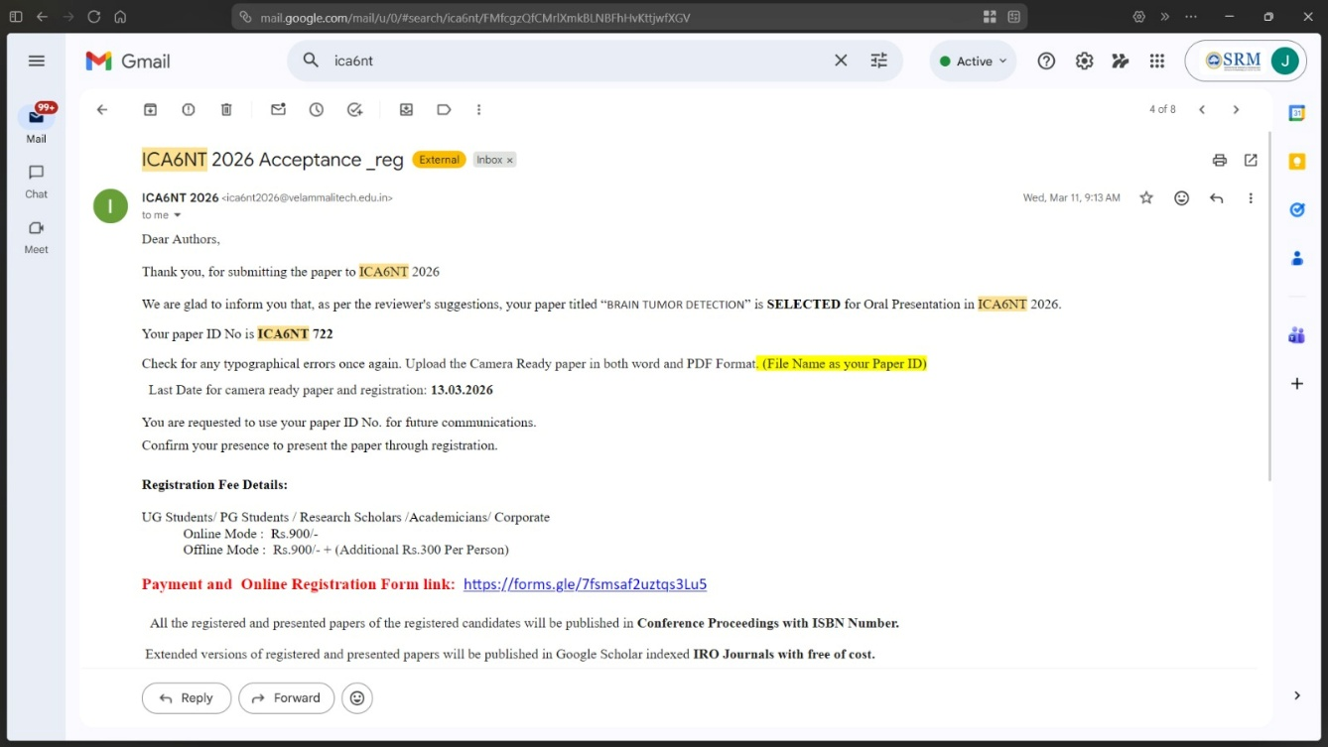
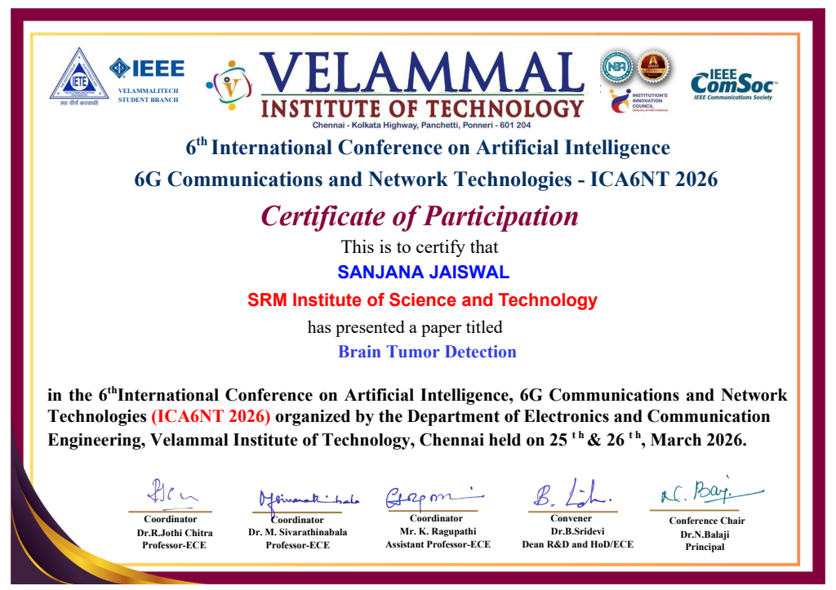
APPENDIX C

PUBLICATION DETAILS


APPENDIX D
PLAGIARISM REPORT
